Magic Invitational: Ishii Yoshikazu
Ishii Yoshikazu
Special thanks to Ron Foster for his translation.
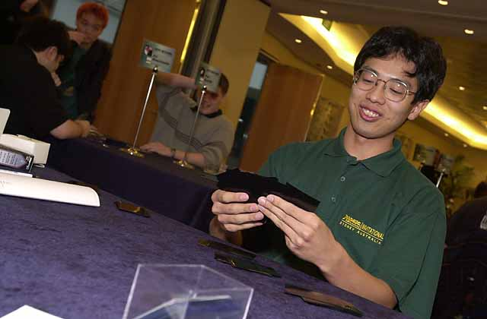
It all began with an early morning phone call.
Wiping the sleep from my eyes, I picked up the receiver and said "Hello?"
The voice on the other end told me something I never thought I would hear: I had been invited to the Magic Invitational.
I also never thought I would have so little time to prepare. When I accepted the Invitation, there were only two weeks before the event began, meaning I had next to no time to prepare. Even though my final ranking was the best a Japanese player has done so far, I still think I could have done better had I more time--maybe a month--to prepare.

Remember when you first learned how to play Magic? How every match was special, filled with... well, with magic?
Still, I had a great time at the Invitational. All of my matches were memorable--so much so that I could probably fill an entire book with all the fun times I had, both playing Magic and otherwise. So instead of writing a traditional report, filled with line after line of who played what and who beat who, I'd like to write about my experiences as an everyday, ordinary Magic player who somehow got lucky enough to get caught up in the greatest Magic event there is.
The other players meet regularly and know each other from the Pro Tour, World Championships, and other high-level events. Not me. I can count on one hand the number of times I've been to the Pro Tour, and I certainly have never done well enough there to be paired up with one of the best players. It's still a mystery to me how I managed to get invited to the Invitational in the first place. In a sense, I was an outsider--I didn't really belong there. Here's the story of a middle-of-the-road average joe at the Magic Invitational.
All the players were extremely relaxed as they played. I hardly understand any English at all, but even I--a random Japanese player--was able to enjoy myself. Indeed, I had more fun playing Magic at the Invitational than I've ever had in my life. I couldn't get over the fact that I was playing with the biggest names in Magic--people I'd read about dozens of times in magazines or the Internet.
Remember when you first learned how to play Magic? How every match was special, filled with... well, with magic? How you couldn't imagine you'd lived so long without discovering such an incredible game? That's how I felt throughout the week. I can't remember how many years it had been since I sat down and had so much fun just playing Magic.
My enjoyment of the trip was only enhanced by the surroundings. Unfortunately, we weren't able to go outside as it was raining almost the entire time, but the Star City Hotel had enough diversions to keep all of us occupied. The restaurants all offered good food, and then there was the casino. As I quickly discovered, Australia is a country that loves to bet-on anything. What I found most interesting, however, was that the majority of the guests in the casino were Chinese, Koreans, and other Asians. The only problem with the hotel was that it was simply immense-I think I spent more time getting lost than I did doing anything else.
Although it was my first trip to Australia, and I can't speak English, I didn't have too much trouble, as the people were friendly and helpful, and Wizards also brought along Ron Foster, a staff member who can speak Japanese, who helped me get around.

I had some problems during the day-including a triple mulligan when playing Noah...
The first day of the Invitational was taken up by sightseeing. At least, that was the plan, but due to the rain none of us were too excited about leaving the bus. We ended up returning to the hotel ahead of schedule. There was a dinner that night with Wizards staff at one of the restaurants in the hotel.
The second day, we began playing with Duplicate Sealed and BYOB. This was my first time playing Duplicate Sealed, but even though I had been nervous ever since I'd arrived and met the other participants, as soon as I touched the cards I relaxed. My opponents for the day were Noah Boeken, Zvi Mowshowitz, Mike Long, Gary Wise, and Dave Price. Although I had some problems during the day-including a triple mulligan when playing Noah-I somehow managed to come out ahead, with a 3-2 record.
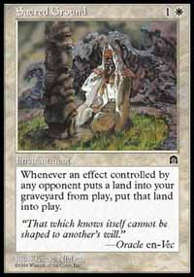
The third day continued with BYOB and Solomon Draft. On this day, I made a lot of mistakes I normally wouldn't make. I think the fatigue of the trip caught up with me. I remember losing a match to Alex Shvartsman because I misread a card. I think the fact that I was actually at the Invitational also caught up with me, making me nervous. I posted a 1-3 record against my opponents for the day-Darwin Kastle, Alex Shvartsman, Bob Maher Jr., and Kai Budde.
The fourth day wound up the Invitational with the Auction of Champions and Classic. I was feeling the pressure-if I won all my matches for the day, I still might have a chance at making the Finals. I wanted to get Michael Loconto's deck in the Auction, as I felt I could play that one most effectively, but I ended up with Jakub Slemr's deck. I felt like I had been set up, because as soon as I put in a bid, everyone else sat down, almost as if on cue.
Still, it wasn't a bad deck, and I felt I had a chance depending on my matchups, but that ended up being wishful thinking on my part.
For Vintage, I played an anti-The Deck deck, which Gary Wise told me was so full of hate it was "ridiculous." I felt this was the safest choice, as given the little time I had to prepare I wasn't able to think much about the Vintage metagame. Still, I assumed that most people would go for control decks or combo decks like Replenish filled with Power Nine cards, so I chose a deck that could stop them. In retrospect, I feel I made the right choice, but I made some mistakes with my sideboard choices. On this last day of the Invitational, I played the remaining Invitationalists: Trevor Blackwell, Ben Rubin, Jon Finkel, Ryan Fuller, Chris Pikula, and Gerardo Godinez.
On the fifth day, while the Finals were taking place, I was asked to gunsling. This is something I wouldn't otherwise have a chance to do, and I enjoyed myself immensely. I was a little jealous of my friend who was trading cards nearby, though-the line of people who wanted to trade with him was longer than the line of people who wanted to play with me.
When we held the awards presentation, I was pleasantly surprised to find that I had tied for 5th place, much better than I expected. What meant most to me were the compliments I received from my friend Satoshi Nakamura, a former Invitationalist who was there attending Grand Prix Sydney.
Afterward, we all went to a barbecue with the Wizards staff. Since we had to use chopsticks, the other Invitationalists talked me into showing them how to properly use chopsticks. Although there were some people, especially Alex, who became very proficient with them, most people struggled. In return they taught me how to pour water-not that I really needed to learn.
And so my first Invitational came to a end.
I skipped over the details of all my matches, but I suppose Mark Rosewater will get upset with me if I don't talk about at least one of them. Although all of my matches were fun and full of good stories, I suppose the one I'll always remember is when I played Gary Wise.
Gary is well known for his love of Japan as well as his friendly manner. From the very first day, seeing I was nervous, he was especially considerate to me, and went out of his way to try to make me feel comfortable. Gary was my first matchup for BYOB. Unfortunately for Gary, my deck was stacked against him. If there was anyone Gary absolutely didn't want to get paired up against, it was me. Gary admitted this, commenting that he'd "be lucky to win 3 out of a hundred games."
Gary was playing an Orim's Prayer-Humility deck that used Kjeldoran Outpost to win. I was of using a Fires Yavimaya deck with Rofellos and Masticore. During the day, everyone commented on how they had overlooked this combination and so were unprepared for it. All the players and the staff, including Mark Rosewater, quickly nominated my deck as one of their favorites to emerge from the format. Unfortunately, the deck wasn't able to produce a winning record due to my mistakes in playing it.
Anyway, I won my first game with Gary with the uncounterable Kavu Chameleon and Keldon Necropolis. While we were looking through our sideboards, Gary stops and pins me down with his eyes.
"Hey--how many Chameleons you got?"
Seeing as this wasn't a sanctioned tournament, and there's no "tech" to keep secret, I told him--4.
Gary rolled his eyes at this response and made a snorting sound.
"How many Urza's Rages?"
"4, of course."
I think everyone can guess his reaction.
After the match was finished, Gary asked if I wouldn't mind showing him my deck. I was interested in seeing the exact make-up of his deck as well, so we swapped decks. That's when the commentary began.
(pointing to Kavu Chameleon) "I really hate this card, you know."
"What the heck do you need 4 Obliterates for!?"
(holding up Keldon Necropolis) "What the heck is this--a Standard deck!?"
"Tectonic Instability!?"
With the last, I thought he was going to jump across the table and choke me. For a brief second, the look in his eyes made me think he was serious.
I think this exchange shows in microcosm what the Invitational is all about. Partly because there were only 16 of us, we were all able to watch each other play, as well as play everyone who was there, and talk about it afterward. It was really no different than being in a local card shop, one where you go to meet your friends--and make new ones--while having a fun game or two of Magic.
That's when I realized something I hadn't before.
These pros, the most famous players in the world--they're no different from me or any other player.
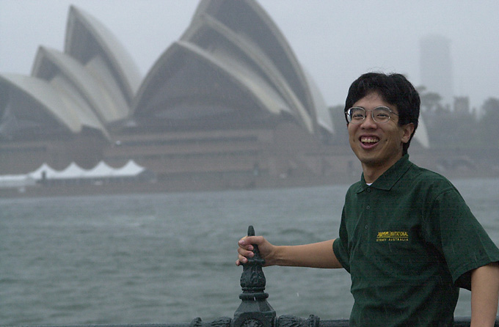
Thanks to Wizards of the Coast for inviting me. It's an experience I'll never forget, and I hope someday I can again be a part of the Invitational.
Thanks to all the Invitational players who put up with me and my poor English throughout the week, especially Gary Wise.
Thanks to Ron Foster, for all your help during the week. I promise I'll return all the cards I borrowed from you.
Thanks to Ryutaro Yamaguchi and Futoshi Iwata, for helping me build my BYOB and Vintage decks. Finally, thanks to everyone who read this report.
Ishii Yoshikazu

